Welcome to Enriched Academy Parents and Graduates!
A personal finance course for all 2023 Graduates
Dear parents,
We know financial literacy is a critical life skill for our students. With the impacts our economy has had over the last two years, understanding the basics around money management has never been more important.
We are excited to introduce a new resource for students this year to learn about money: Enriched Academy. Enriched Academy is fully funded by the Alberta government for all graduating students and is Canada’s leading online personal financial education program, providing financial literacy training through online courses and tools. Enriched Academy covers budgeting, credit cards, credit score, student loans, investing, insurance, taxes and much more.
We are happy to announce that all 2023 Graduates will receive a personal licence for Enriched Academy with lifetime access to the program. The self-paced modules and tools will allow them to complete the course this year or upon graduation. The attached flyer will outline how your child will be able to access their account and a “how to” video.
We hope this program will help prepare our graduates for the future, wherever their journey will take them.
As your child’s school email will no longer be valid after graduation, they will need to add a personal email to your profile. Click on name, then profile, add a personal email under “Alternate email”, click make primary, and click Update.
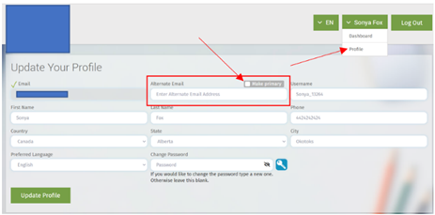
Sincerely,

P.S. In the event your child has forgotten their login details, they can simply use the “Forgot Password” function on the Enriched Academy’s homepage.

